

Supplementary Materials for

**Adaptive Interference Avoidance Response in Group Flying Bats**

Paste the full author list here (no paragraph breaks)

Corresponding author: [xxxxx@xxxx.xxx](mailto:xxxxx@xxxx.xxx)

**The PDF file includes:**

Materials and Methods

Figs. S1 to S4

Tables S1 to S5

References 29 - 33

Materials and Methods

Subjects

The bats used in the experiment were adult male great Himalayan leaf-nosed bats (*Hipposideros armiger*) (Fig. S1), captured from a natural cave in Xiaonanhai Town, Nanzheng District, Hanzhong City, Shaanxi Province, China. The echolocation calls emitted by the bats consist of a relatively long CF portion and are accompanied by a brief downward terminal FM component. The bats emit multi-harmonic echolocation sounds, of which the second harmonic of the CF components (CF2) is the most prominent. The bats exhibit a DSC behaviour to compensate for the echo CF2 frequency, which slightly varies between individuals in a colony.

Experimental procedure

All experiments were conducted in a custom-built experimental chamber (length 5 m × width 3 m × height 3 m). Three sides of the chamber were enclosed by walls, while one side was covered with a hanging net. In order to authentically assess the variations in pulses during flight, acoustic foam was not used, ensuring the chamber retained echoes. This setup was crucial for simulating the highly interfering environment of bats in group flight, thereby facilitating the observation of parameter changes under interference conditions.

Each day, we randomly captured 15-20 wild bats, which were then grouped into various sizes ranging from 1 to 10 bats, with some overlapping, resulting in a total of 30 groups, each group size being replicated 3 times. Experimenters simultaneously released all the bats in each group in front of the net, encouraging them to fly towards the net. Typically, the bats would fly from in front of the net to the net itself and then hang there to rest. Consequently, we repeated the releases multiple times and only recorded signals from the flight path leading directly to the net. This variation in group size facilitated the observation of the relationship between pulse parameters and the number of bats. After each recording session we released the bats at site of capture either immediately after trials or within their roost the following day. All bats were released within 24 hours of capture.

Sound recordings

Each bat's echolocation pulses were recorded by two microphone arrays fixed on the ground. These microphone arrays were positioned in front of the net to ensure the reception of signals originating from the front. Both the microphones and the arrays were custom-developed, with each array consisting of 64 microphones (Fig. S2). The azimuth main lobe width is 3°and the elevation is 4°, and the peak sidelobe level was -10dB (Fig. S3), enabling the direction finding and separation of bats in group flight. The 128 channels of phase-coherent signals were sampled using an ART Technology DATA acquisition device at a rate of 250 kHz per channel (16-bit). Our files were stored on a laptop using ACTS3201 software. All channels were synchronized using a common clock (Fig. S4).

Sound analysis

We processed the recordings using a custom MATLAB script. Initially, a Chebyshev bandpass filter, with passband cutoff frequencies between 58000-74000Hz and stopband cutoff frequencies at 54000 and 79000Hz, is employed to refine the signal, ensuring passband and stopband attenuation (0.1 and 30, respectively). Subsequently, each channel's signal is downconverted to a zero frequency, followed by the application of the MUSIC algorithm to estimate the azimuth and elevation angles of bats relative to two arrays. Beamforming is then applied to the multi-channel signals based on these angular estimates, using the LCMV adaptive beamforming algorithm to enhance signals in the expected direction and suppress others, thereby improving the signal-to-noise ratio by approximately 18.06dB. The results of beamforming from two arrays are cross-correlated to determine the time differences in arrival. Then, we utilized multi-station passive localization algorithms based on a hybrid of Time Difference of Arrival (TDOA) and Angle of Arrival (AOA) to calculate the 3D coordinates of the bats as they emitted each echolocation call. The study further integrates signal matching with individual bats based on angular and positional data, and estimates flight speed using the positional data and time differences at two distinct moments. Utilizing a second custom MATLAB script, we created visual representations of these 3D coordinates. This visualization enabled us to visually screen the files and select only those with unambiguous flight paths for sound analysis. In each situation, files were chosen for further analysis only when the flight paths indicated that multiple bats were flying simultaneously.

We then analyzed the selected recordings with clear flight paths. Using a custom-written MATLAB script, pulses were manually analyzed from the spectrograms of the microphone recordings. The frequency and duration of the CF component, as well as the duration and bandwidth of the FM component, were analysed using a WVD (Wigner-Ville Distribution) transformation with 5000 points, achieving a temporal resolution of 0.004ms, a frequency resolution determined by the actual duration of the signal, a time measurement accuracy of 0.004ms and a frequency measurement precision of 30Hz. All acoustic parameters were manually marked on the spectrogram and verified through visual inspection.

Estimating the echo frequency differences

Bats emit echolocation pulses to navigate and fly by analyzing the reflected echoes. When multiple conspecifics are present, the echoes become complex. With bats flying in the same direction simultaneously, the directionality of pulse emission and auditory reception facilitates the differentiation of direct calls from other bats (*27*-*29*). Instead, bats receive echoes of their own calls as well as secondary echoes from calls of others after reflection off objects. By analyzing the microphone array received signals, it is possible to estimate the frequency difference between these two echoes. We use two bats as an example to derive the estimation relationship for the frequency difference between the echoes. These estimations were conducted using custom-written MATLAB script.

In the experiment, the signals recorded by the microphone are influenced by the Doppler effect due to the relative motion between the bats and the microphone.

|  |  |
| --- | --- |
|  |  |
|  |  |

where  and  represent the CF frequency received by the microphone,  and  represent the original emission frequencies,  and  represent the velocity vectors of the bats,  and  represent the angles between the velocity vectors of the bats and the line between the bats and the microphone array, respectively,  represents the wavelength and . For the *Hipposideros armiger*, the CF frequency is approximately 69,000 Hz. An estimation based on the relationship between the beam directivity and frequency and species suggests that  and .

Echolocation interference originates not only from reflections off a microphone array but also from reflections within other area in the environment. The frequency of the signals received in these actual interference areas is as follows:

|  |  |
| --- | --- |
|  |  |
|  |  |

In the formula, the definitions of each variable remain consistent with previous instances; however, the source of reflection shifts from the microphone array to other areas.

One bat served as the focal individual, and the echoes it received were comprised of two aspects. On one hand, there are echoes resulting from the reflection of its own calls. On the other hand, there are secondary echoes, which are the pulses of other bats that have reflected off objects and subsequently propagated to the focal bat.

|  |  |
| --- | --- |
|  |  |
|  |  |

where  represents the echoes from the bat itself, while  represents the secondary echoes from other bats. The difference in the CF of these two echoes can be represented as follows:

|  |  |
| --- | --- |
|  |  |

Given that  cannot be directly obtained, we estimate the frequency difference of the actual return echoes by using the difference in the CF of signals received by the microphone array:

|  |  |
| --- | --- |
|  |  |

Due to errors arising from the differences in relative angles between the actual reflection areas, the microphone array, and the bat, this error can be represented as:

|  |  |
| --- | --- |
|  |  |

When the interference area overlaps with the microphone array,  can be represented by . Subsequently, by considering the theoretical ranges of , , , , , , and spatial coordinates, we estimate the distribution of the. Assuming that the spatial coordinates of a bat , a microphone array , and a reflecting area . To ensure a high degree of overlap in the perceptual fields among bats, individuals are encouraged to fly in the same direction. The coverage of the perceptual field, determined by beam width and vocalization intensity, must encompass all areas ahead, requiring the following conditions to be met , and given that , , , , , we can establish a mathematical relationship between the angles  and  with respect to , which is the angle between the vectors AB and AC: . We randomly generate 10,000,000 points to acquire a distribution of the angle . We select a random sample of points directly from the dataset to estimate the angle deviation  without introducing bias from estimated distribution. Based on the statistical results, the flight speed follows a normal distribution with a mean of 1.5 and a standard deviation of 0.5.

Given the distribution of each variable is known, we derive the error distribution for frequency difference:

|  |  |
| --- | --- |
|  |  |

The error is normally distributed in space, with a mean of 0.31 Hz and a standard deviation of 45 Hz. Under a 95% confidence interval, the range of error can be determined. Results are considered more reliable when the frequency adjustment exceeds twice the standard deviation, that is, 90 Hz.

Due to the irregular timing of signal emission by bats, which prevents them from vocalizing simultaneously, we have estimated an average silence duration of 25 ms. This duration serves as the time window for calculating frequency differences (*30*, *31*), ensuring that interference with each pulse is accounted for.

Estimating the source pressure level of bat calls

We utilized a custom MATLAB script to estimate the source levels of bat echolocation calls. Specifically, the recorded calls were first processed using band-pass filtering. Subsequently, a Short-Time Fourier Transform (STFT) was applied to perform time-frequency analysis of the recordings, allowing us to calculate the peak energy of each pulse. By correlating these energy values with the peak amplitude of the signal envelope, we estimated the sound pressure levels (SPL) of the recorded signals. Finally, taking into account the atmospheric attenuation of the signal, we estimated the true source levels of the echolocation calls. The detailed steps are as follows:

First, the reference signal envelope peak amplitude  is set to 0.0025, with the corresponding peak energy  after the STFT being -1 dB. The STFT is performed with a window length of 2048, a step size of 128, an FFT size of , and using a Blackman window.

Next, the peak energy  of each pulse after STFT is used to estimate the signal peak amplitude . Given the energy change , the amplitude change factor . The estimated signal peak amplitude is .

The sound pressure level (SPL) is calculated from the amplitude . Given a reference voltage  for the analog-to-digital converter of 1.2 V and a microphone sensitivity of -42 dB re 1V/Pa, the actual microphone voltage of the sound is .

The conversion from microphone voltage to sound pressure is:

|  |  |
| --- | --- |
|  |  |

The SPL calculation formula is:

|  |  |
| --- | --- |
|  |  |

where the reference sound pressure  is 20 .

Atmospheric attenuation is estimated based on the 3D position of the pulse using the formula:

|  |  |
| --- | --- |
|  |  |

The attenuation coefficient  is calculated as:

|  |  |
| --- | --- |
|  |  |

where , , relative humidity is 30%, atmospheric pressure is 101000 Pa, and is the distance between the bat and the microphone array.

Finally, the estimated SPL is compensated for atmospheric attenuation to obtain the source level.

Statistical analysis

We used Python for all statistical analyses. All tests were two-tailed (=0.05). Our data did not meet all of the assumptions of ANOVA, therefore we used equivalent non-parametric tests. We compared the durations of CF and FM, as well as the bandwidth, emission rate and source pressure level across different group sizes. Kruskal-Wallis tests and, if significant, Dunn's post hoc test were utilized. When comparing the variations in acoustic parameters between two points in time, the Wilcoxon Signed-Rank test was used for non-parametric comparisons on each pair. Results are presented as mean ± SD, unless otherwise stated.

Linear regression analysis was conducted to explore the presence of a linear relationship between two variables. The p-value was used to determine the statistical significance of this linear relationship, while the correlation coefficient R provided a measure of the strength of the linear association, with values close to 1 or -1 indicating strong positive or negative relationships, respectively, and values near 0 suggesting a weak relationship. The coefficient of determination R² indicated the proportion of the variance in the dependent variable that is predictable from the independent variable. Values close to 1 imply that the model explains a significant proportion of the variance, whereas values near 0 suggest a lower level of explanatory power.

Fig. S1.

One individual of a great Himalayan leaf-nosed bat (*Hipposideros armiger*).

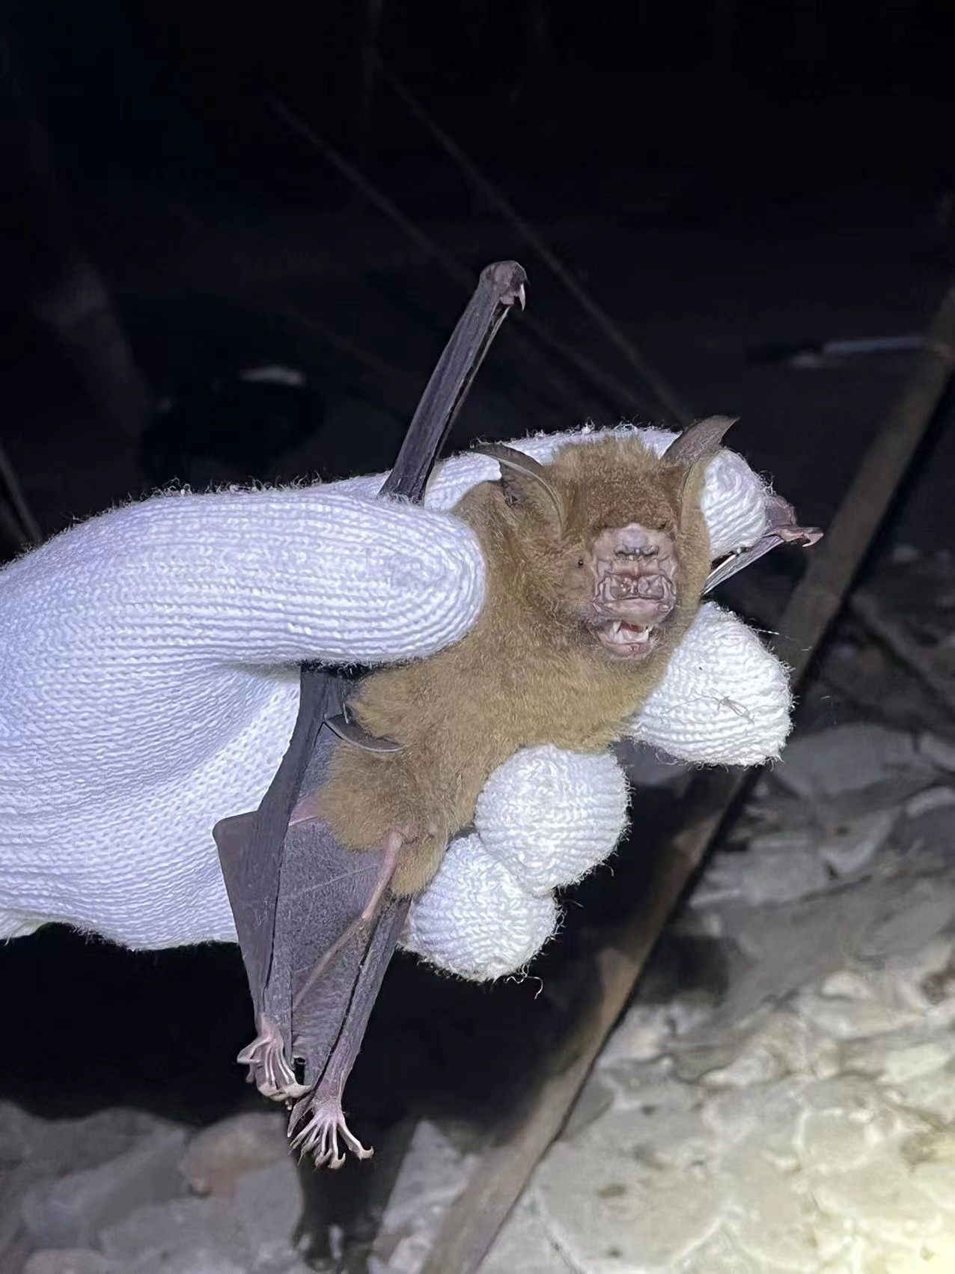

Fig. S2.

The designed microphone array. The left figure shows the theoretical microphone distribution, while the right figure displays the prototype array.

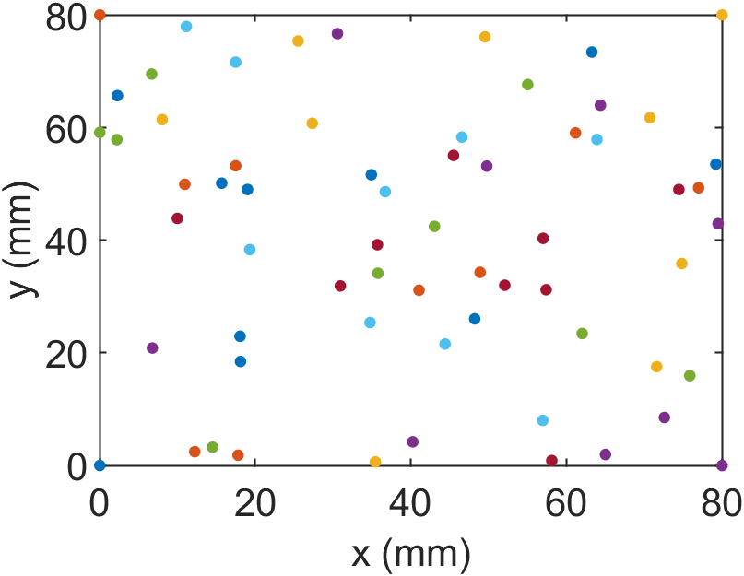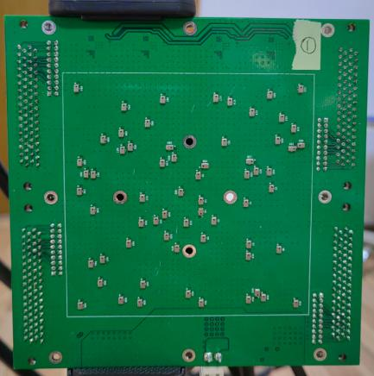

Fig. S3.

The azimuth directional pattern and elevation directional pattern for designed microphone array.

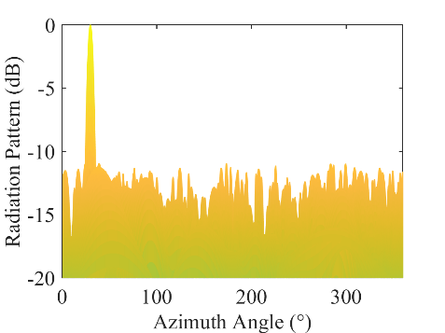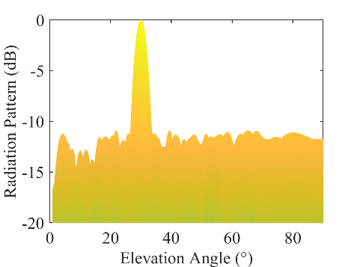

Fig. S4.

The systematic experimental setup. It includes two 64-microphone arrays, a 128-channel data acquisition unit, and custom-developed signal processing algorithms based on MATLAB.

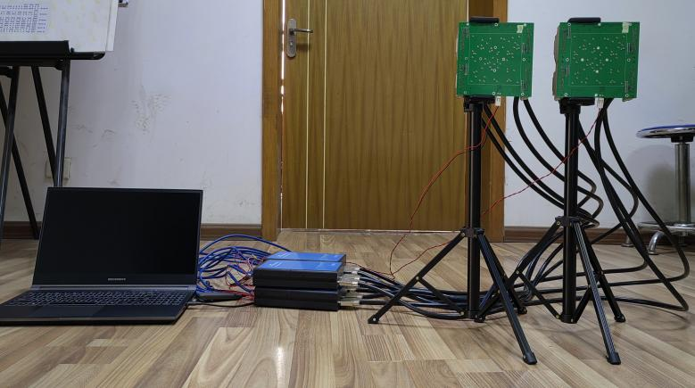

|  |  |  |  |
| --- | --- | --- | --- |
| group1 | group2 | p | reject |
| 1 | 2 | 1.0 | False |
| 1 | 3 | 0.5909 | False |
| 1 | 4 | 0.0 | True |
| 1 | 5 | 0.0 | True |
| 1 | 6 | 0.0003 | True |
| 1 | 7 | 0.002 | True |
| 1 | 8 | 0.0139 | True |
| 1 | 9 | 0.0531 | False |
| 1 | 10 | 0.0023 | True |
| 2 | 3 | 0.7881 | False |
| 2 | 4 | 0.0 | True |
| 2 | 5 | 0.0 | True |
| 2 | 6 | 0.0018 | True |
| 2 | 7 | 0.0101 | True |
| 2 | 8 | 0.0539 | False |
| 2 | 9 | 0.1275 | False |
| 2 | 10 | 0.012 | True |
| 3 | 4 | 0.001 | True |
| 3 | 5 | 0.0 | True |
| 3 | 6 | 0.0718 | False |
| 3 | 7 | 0.2944 | False |
| 3 | 8 | 0.7746 | False |
| 3 | 9 | 0.89 | False |
| 3 | 10 | 0.3424 | False |
| 4 | 5 | 0.0067 | True |
| 4 | 6 | 0.9726 | False |
| 4 | 7 | 0.5725 | False |
| 4 | 8 | 0.0468 | True |
| 4 | 9 | 0.4086 | False |
| 4 | 10 | 0.3599 | False |
| 5 | 6 | 0.0 | True |
| 5 | 7 | 0.0 | True |
| 5 | 8 | 0.0 | True |
| 5 | 9 | 0.0 | True |
| 5 | 10 | 0.0 | True |
| 6 | 7 | 0.999 | False |
| 6 | 8 | 0.7432 | False |
| 6 | 9 | 0.9709 | False |
| 6 | 10 | 0.992 | False |
| 7 | 8 | 0.9909 | False |
| 7 | 9 | 0.9999 | False |
| 7 | 10 | 1.0 | False |
| 8 | 9 | 1.0 | False |
| 8 | 10 | 0.9976 | False |
| 9 | 10 | 1.0 | False |

Table S1. Dunn's Post Hoc Test Results for CF Duration Under Various Flight Conditions. The results, presented in a table, demonstrate whether significant differences exist between groups. The numbers in the 'group' column represent the number of bats flying, ranging from a single bat flying alone to groups of up to ten bats. The 'True' suggests a significant difference (p < 0.05), whereas 'False' suggests no significant difference.

|  |  |  |  |
| --- | --- | --- | --- |
| group1 | group2 | p | reject |
| 1 | 2 | 1.0 | False |
| 1 | 3 | 0.0 | True |
| 1 | 4 | 0.0 | True |
| 1 | 5 | 0.0 | True |
| 1 | 6 | 0.0 | True |
| 1 | 7 | 0.0 | True |
| 1 | 8 | 0.0 | True |
| 1 | 9 | 0.0 | True |
| 1 | 10 | 0.0 | True |
| 2 | 3 | 0.0002 | True |
| 2 | 4 | 0.0 | True |
| 2 | 5 | 0.0 | True |
| 2 | 6 | 0.0 | True |
| 2 | 7 | 0.0 | True |
| 2 | 8 | 0.0 | True |
| 2 | 9 | 0.0 | True |
| 2 | 10 | 0.0 | True |
| 3 | 4 | 0.0 | True |
| 3 | 5 | 0.0022 | True |
| 3 | 6 | 0.0 | True |
| 3 | 7 | 0.0 | True |
| 3 | 8 | 0.0 | True |
| 3 | 9 | 0.0 | True |
| 3 | 10 | 0.0 | True |
| 4 | 5 | 0.0521 | False |
| 4 | 6 | 0.0 | True |
| 4 | 7 | 0.0803 | False |
| 4 | 8 | 0.0001 | True |
| 4 | 9 | 0.0 | True |
| 4 | 10 | 0.0 | True |
| 5 | 6 | 0.0 | True |
| 5 | 7 | 0.0 | True |
| 5 | 8 | 0.0 | True |
| 5 | 9 | 0.0 | True |
| 5 | 10 | 0.0 | True |
| 6 | 7 | 0.0205 | True |
| 6 | 8 | 0.3797 | False |
| 6 | 9 | 1.0 | False |
| 6 | 10 | 0.9971 | False |
| 7 | 8 | 0.8955 | False |
| 7 | 9 | 0.2721 | False |
| 7 | 10 | 0.0922 | False |
| 8 | 9 | 0.9165 | False |
| 8 | 10 | 0.8285 | False |
| 9 | 10 | 1.0 | False |

Table S2. Dunn's Post Hoc Test Results for FM Bandwidth Under Various Flight Conditions.

|  |  |  |  |
| --- | --- | --- | --- |
| group1 | group2 | p | reject |
| 1 | 2 | 1.0 | False |
| 1 | 3 | 0.0002 | True |
| 1 | 4 | 0.0 | True |
| 1 | 5 | 0.0 | True |
| 1 | 6 | 0.0 | True |
| 1 | 7 | 0.0 | True |
| 1 | 8 | 0.0 | True |
| 1 | 9 | 0.0 | True |
| 1 | 10 | 0.0 | True |
| 2 | 3 | 0.001 | True |
| 2 | 4 | 0.0 | True |
| 2 | 5 | 0.0 | True |
| 2 | 6 | 0.0 | True |
| 2 | 7 | 0.0 | True |
| 2 | 8 | 0.0 | True |
| 2 | 9 | 0.0 | True |
| 2 | 10 | 0.0 | True |
| 3 | 4 | 0.5071 | False |
| 3 | 5 | 0.9143 | False |
| 3 | 6 | 0.0 | True |
| 3 | 7 | 0.0 | True |
| 3 | 8 | 0.0 | True |
| 3 | 9 | 0.0 | True |
| 3 | 10 | 0.0 | True |
| 4 | 5 | 0.9972 | False |
| 4 | 6 | 0.0 | True |
| 4 | 7 | 0.0 | True |
| 4 | 8 | 0.0 | True |
| 4 | 9 | 0.0002 | True |
| 4 | 10 | 0.0 | True |
| 5 | 6 | 0.0 | True |
| 5 | 7 | 0.0 | True |
| 5 | 8 | 0.0 | True |
| 5 | 9 | 0.0 | True |
| 5 | 10 | 0.0 | True |
| 6 | 7 | 0.6281 | False |
| 6 | 8 | 0.9713 | False |
| 6 | 9 | 0.7359 | False |
| 6 | 10 | 0.3306 | False |
| 7 | 8 | 0.9943 | False |
| 7 | 9 | 1.0 | False |
| 7 | 10 | 1.0 | False |
| 8 | 9 | 0.9952 | False |
| 8 | 10 | 0.9247 | False |
| 9 | 10 | 1.0 | False |

Table S3. Dunn's Post Hoc Test Results for FM Duration Under Various Flight Conditions.

|  |  |  |  |
| --- | --- | --- | --- |
| group1 | group2 | p | reject |
| 1 | 2 | 1.0 | False |
| 1 | 3 | 0.0131 | True |
| 1 | 4 | 0.0181 | True |
| 1 | 5 | 0.0352 | True |
| 1 | 6 | 0.0313 | True |
| 1 | 7 | 0.0743 | False |
| 1 | 8 | 0.0002 | True |
| 1 | 9 | 0.0003 | True |
| 1 | 10 | 0.0504 | False |
| 2 | 3 | 0.188 | False |
| 2 | 4 | 0.266 | False |
| 2 | 5 | 0.4084 | False |
| 2 | 6 | 0.42 | False |
| 2 | 7 | 0.6167 | False |
| 2 | 8 | 0.0292 | True |
| 2 | 9 | 0.0517 | False |
| 2 | 10 | 0.5609 | False |
| 3 | 4 | 1.0 | False |
| 3 | 5 | 0.9993 | False |
| 3 | 6 | 0.998 | False |
| 3 | 7 | 0.9667 | False |
| 3 | 8 | 0.9999 | False |
| 3 | 9 | 1.0 | False |
| 3 | 10 | 0.9723 | False |
| 4 | 5 | 1.0 | False |
| 4 | 6 | 1.0 | False |
| 4 | 7 | 0.9953 | False |
| 4 | 8 | 0.9942 | False |
| 4 | 9 | 0.9999 | False |
| 4 | 10 | 0.9967 | False |
| 5 | 6 | 1.0 | False |
| 5 | 7 | 0.9999 | False |
| 5 | 8 | 0.9152 | False |
| 5 | 9 | 0.9853 | False |
| 5 | 10 | 1.0 | False |
| 6 | 7 | 1.0 | False |
| 6 | 8 | 0.8536 | False |
| 6 | 9 | 0.9647 | False |
| 6 | 10 | 1.0 | False |
| 7 | 8 | 0.5523 | False |
| 7 | 9 | 0.7632 | False |
| 7 | 10 | 1.0 | False |
| 8 | 9 | 1.0 | False |
| 8 | 10 | 0.5612 | False |
| 9 | 10 | 0.7748 | False |

Table S4. Dunn's Post Hoc Test Results for Emission Rate Under Various Flight Conditions.

|  |  |  |  |
| --- | --- | --- | --- |
| group1 | group2 | p | reject |
| 1 | 2 | 1.0000 | False |
| 1 | 3 | 0.6527 | False |
| 1 | 4 | 1.0000 | False |
| 1 | 5 | 1.0000 | False |
| 1 | 6 | 0.0114 | True |
| 1 | 7 | 0.0224 | True |
| 1 | 8 | 0.2658 | False |
| 1 | 9 | 0.8579 | False |
| 1 | 10 | 0.1216 | False |
| 2 | 3 | 1.0000 | False |
| 2 | 4 | 1.0000 | False |
| 2 | 5 | 1.0000 | False |
| 2 | 6 | 1.0000 | False |
| 2 | 7 | 1.0000 | False |
| 2 | 8 | 1.0000 | False |
| 2 | 9 | 1.0000 | False |
| 2 | 10 | 1.0000 | False |
| 3 | 4 | 1.0000 | False |
| 3 | 5 | 1.0000 | False |
| 3 | 6 | 1.0000 | False |
| 3 | 7 | 1.0000 | False |
| 3 | 8 | 1.0000 | False |
| 3 | 9 | 1.0000 | False |
| 3 | 10 | 1.0000 | False |
| 4 | 5 | 1.0000 | False |
| 4 | 6 | 0.4605 | False |
| 4 | 7 | 0.7571 | False |
| 4 | 8 | 1.0000 | False |
| 4 | 9 | 1.0000 | False |
| 4 | 10 | 1.0000 | False |
| 5 | 6 | 1.0000 | False |
| 5 | 7 | 1.0000 | False |
| 5 | 8 | 1.0000 | False |
| 5 | 9 | 1.0000 | False |
| 5 | 10 | 1.0000 | False |
| 6 | 7 | 1.0000 | False |
| 6 | 8 | 1.0000 | False |
| 6 | 9 | 1.0000 | False |
| 6 | 10 | 1.0000 | False |
| 7 | 8 | 1.0000 | False |
| 7 | 9 | 1.0000 | False |
| 7 | 10 | 1.0000 | False |
| 8 | 9 | 1.0000 | False |
| 8 | 10 | 1.0000 | False |
| 9 | 10 | 1.0000 | False |

Table S5. Dunn's Post Hoc Test Results for Sound Pressure Level Under Various Flight Conditions.

References

1. L. Jakobsen, J. M. Ratcliffe, A. Surlykke, Convergent acoustic field of view in echolocating bats. *Nature* **493**, 93-96 (2013).
2. N. Matsuta, S. Hiryu, E. Fujioka, Y. Yamada, H. Riquimaroux, Y. Watanabe, Adaptive beam-width control of echolocation sounds by CF–FM bats, *Rhinolophus ferrumequinum nippon*, during prey-capture flight. *Journal of Experimental Biology* **216**, 1210-1218 (2013).
3. U. Firzlaff, G. Schuller, Directionality of hearing in two CF/FM bats, *Pteronotus parnellii* and *Rhinolophus rouxi*. *Hearing research* **197**, 74-86 (2004).
4. J. Luo, C. F. Moss, Echolocating bats rely on audiovocal feedback to adapt sonar signal design. *Proceedings of the National Academy of Sciences* **114**, 10978-10983 (2017).
5. S. R. Hage, T. Jiang, S. W. Berquist, J. Feng, W. Metzner, Ambient noise induces independent shifts in call frequency and amplitude within the Lombard effect in echolocating bats. *Proceedings of the National Academy of Sciences* **110**, 4063-4068 (2013).